Specificity calculation

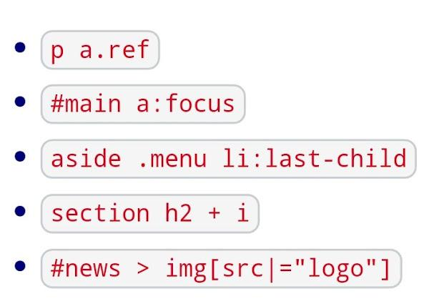

In the given order:

# Specificity:

1. [ 0 , 1 , 2 ] 012
2. [ 1 , 1 , 1] 111
3. [ 0 , 2 , 2] 022
4. [ 0 , 0 , 3] 003
5. [ 1 , 1 , 1] 111

# Ordered:

1. #main a:focus
2. #news > img[SRC|="logo"]
3. aside .menu li:last-child
4. p a.ref
5. Section h2+i

In the case of the two first selectors, they have the same weight, in the case of no one having an **!important** rule the one selected with more specificity is the first one given, so that is why I have ordered them in that way.

For the others I simply ordered the numbers from higher to lower as specificity rules says.